CHAPTER 1

INTRODUCTION

1.1 Computer Graphics

- Graphics provides one of the most natural means of communicating with a computer, since our highly developed 2D or 3D pattern-recognition abilities allow us to perceive and process pictorial data rapidly.
- Computers have become a powerful medium for the rapid and economical production of pictures.
- Graphics provide a so natural means of communicating with the computer that they have become widespread.
- Interactive graphics is the most important means of producing pictures since the invention of photography and television.
- We can make pictures of not only the real-world objects but also of abstract objects such as mathematical surfaces on 4D and of data that have no inherent geometry.
- A computer graphics system is a computer system with all the components of the general-purpose computer system. There are five major elements in system: input devices, processor, memory, frame buffer, output devices.
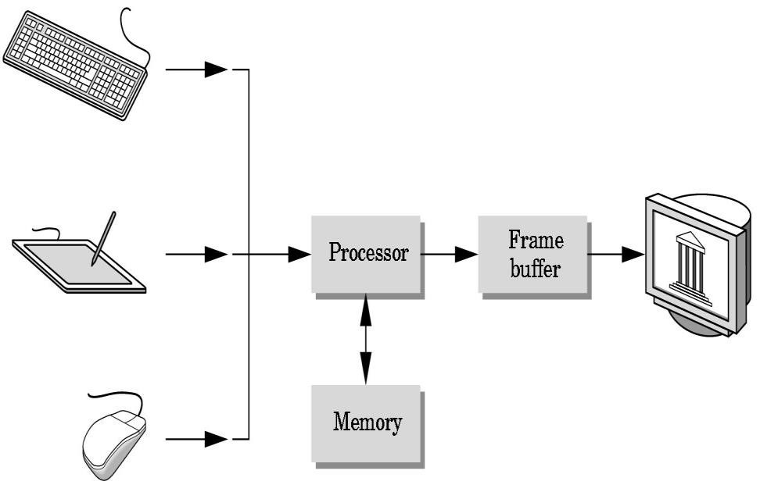
Fig 1.1: Graphic System

1.2 Areas of Application of Computer Graphics
- User interfaces and Process control
- Cartography
- Office automation and Desktop publishing
- Plotting of graphs and charts
- Computer aided Drafting and designs
- Simulation and Animation

1.3 Introduction to OpenGL
OpenGL is the premier environment for developing portable, interactive 2D and 3D graphics applications. Since its introduction in 1992, OpenGL has become the industry’s most widely used and supported 2D and 3D graphics application programming interface (API), bringing thousands of applications to a wide variety of computer platforms.
OpenGL fosters innovation and speeds application development by incorporating a broad set of rendering, texture mapping, special effects, and other powerful visualization functions. Developers can leverage the power of OpenGL across all popular desktop and workstation platforms, ensuring wide application deployment.
OpenGL available Everywhere: Supported on all UNIX® workstations and shipped standard with every Windows 95/98/2000/NT and MacOS PC, no other graphics API operates on a wider range of hardware platforms and software environments.
OpenGL runs on every major operating system including Mac OS, OS/2, UNIX, Windows 95/98, Windows 2000, Windows NT, Linux, Open Step, and BeOS; it also works with every major windowing system, including Win32, MacOS, Presentation Manager, and X-Window System. OpenGL is callable from Ada, C, C++, Fortran, Python, Perl and Java and offers complete independence from network protocols and topologies.

1.3.1 The OpenGL interface

Our application will be designed to access OpenGL directly through functions in three libraries namely: gl , glu , glut.



GL

GLUT

GLX

Xlib, Xtk

Frame

buffer

OpenGL

Application

Program

GLU

Fig 1.2
:

Library organization of OpenGL

1.3.2 Graphics Functions

Function calls Outputs


Application
programs

Graphics
system

Ip/op
devices

Data Input
Fig 1.3: Graphics system as a black box.

Our basic model of a graphics package is a black box, a term that engineers use to denote a system whose properties are described only by its inputs and outputs. We describe an API through the functions in its library. Some of the functions are:
- The primitive functions define the low-level objects or atomic entities that our system can display.
- Attribute functions allow us to perform operations ranging from choosing the color with which we display a line segment, to picking a pattern with which to fill the inside of a polygon, to selecting a typeface for the titles of a graph.
- Transformation function allows carrying out transformations of objects, such as rotation, translation, and scaling.
- A set of input functions allow us to deal with the diverse forms of input that characterize modern graphics systems.
- The control functions enable us to communicate with the window systems, to initialize our programs, and to deal with any errors that take place during the execution of programs.

CHAPTER 2

REQUIREMENTS SPECIFICATION

2.1 Purpose of the requirements document

The software requirement specification is the official statement of what is required for development of particular project. It includes both user requirements and system requirements. This requirement document is utilized by variety of users starting from project manager who gives project to the engineer responsible for development of project.
It should give details of how to maintain, test, verify and what all the actions to be carried out through life cycle of project.

2.1.1 Scope of the project
The scope is to use the basic primitives defined in OpenGL library creating complex objects. We make use of different concepts such as glColor() , gluOrtho2D(), timer function.

2.1.2 Definition
The project LINKED LIST is created to demonstrate OpenGL’s concepts. It encompasses some of the skills learnt in our OpenGL classes such as glColor() , gluOrtho2D(), timer function.
.
2.1.3 Acronyms & Abbreviations
OpenGL provides a powerful but primitive set of rendering command, and all higher-level design must be done in terms of these commands. OpenGL Utility Toolkit(GLUT): -windows-system-independent toolkit.

2.1.4 References
- OpenGL tutorials
- Interactive Computer Graphics (Edward Angel)

2.2 Specific Requirements
2.2.1 User Requirements:
- Easy to understand and should be simple.
- The built-in functions should be utilized to maximum extent.
- OpenGL library facilities should be used.

2.2.2 Software Requirements:
- Platform used: CODE BLOCKS
- Technology used: OpenGL Libraries such has OpenGL Utility library, OpenGL
Utility toolkit
- Language: C

2.2.3 Hardware Requirements:
- Processor-Intel or AMD (Advanced Micro Devices)
- RAM-512MB(minimum)
- Hard Disk-1MB(minimum)
- Mouse
- Keyboard
- Monitor

CHAPTER 3

IMPLEMENTATION

3.1 OpenGL Function Details
- glutInitDisplayMode( ) — sets the initial display mode.
  - Declaration: void glutInitDisplayMode(unsigned int mode);
  - Remarks: The initial display mode is used when creating top-level windows, sub windows, and overlays to determine the OpenGL display mode for the to-be-created window or overlay.
- glutInitWindowposition( ) --- set the initial window position.
▪ Declaration: void glutInitWindowPosition(int x, int y);
x: Window X location in pixels.
y: Window Y location in pixels.
- glutInitWindowSize( ) --- set the initial window size.
▪ Declaration: void glutInitWindowSize(int width, int height);
width: Width in pixels. height: Height in pixels.

- glutCreateWindow( ) --- set the title to graphics window.
    - Declaration: int glutCreateWindow(char *title);
    - Remarks: This function creates a window on the display. The string title can be used to label the window. The integer value returned can be used to set the current window when multiple windows are created.
- glutDisplayFunc( ) :

    - Declaration: void glutDisplayFunc(void (*func)(void));
    - Remarks: This function registers the display function that is executed when the window needs to be redrawn.
- glClear( ) :
  - Declaration: void glClear();
  - Remarks: This function clears the particular buffer.

- glclearColor( ) :
  - Declaration: void glClearColor(GLfloat red, GLfloat green, Glfloat blue, Glfloat alpha);
  - Remarks: This function sets the color value that is used when clearing the color buffer.

- glEnd( ) :
  - Declaration: void glEnd();
  - Remarks: This function is used in conjunction with glBegin to delimit the vertices of an OpenGL primitive.
- glMatrixMode( ) :
  - Declaration: void glMatrixMode(GLenum mode);
  - Remarks: This function specifies which matrix will be affected by subsequent transformations mode can be GL_MODELVIEW, GL_PROJECTION or GL_TEXTURE.

- gluOrtho2D( ) :
▪ | Declaration: void glOrtho(GLdouble left, GLdouble right, GLdouble bottom,GLdouble top);
➢ glutInit( ) : | - Remarks: It defines an orthographic viewing volume with all parameters measured from the center of the projection plane.
▪ | Declaration:
void glutInit(int *argc, char **argv);
  - Remarks: To start through graphics system, we must first call glutInit(), glutInit will initialize the GLUT library and negotiate a session with the window system. During this process, glutInit may cause the termination of the GLUT program with an error message to the user if GLUT cannot be properly initialized.
3.2. Source Code
#include<stdio.h>
#include<conio.h>
#include<stdlib.h>
#include<GL/glut.h>
#include<math.h>
int i;
struct node1 //Singly linked list
{
int info;
struct node1 *link;
};
struct arr1
{
int p;
int q;
}ar[20];
typedef struct node1* NODE1;
static NODE1 first=NULL;
static int count=0,flag=1;
int succ=1,succ1=1,ins_succ=1;
int item,key;
float color[4][3]={{1.0,1.0,1.0},{0.8,0.0,0.0,},{0.0,0.0,0.0},{0.0,0.0,0.8}};
void drawstring(float x,float y,char *string,int col)
{
char *c;
glColor3fv(color[col]);
glRasterPos2f(x,y);
for(c=string;*c!='\0';c++)
glutBitmapCharacter(GLUT_BITMAP_HELVETICA_18,*c);
}
void title()
{
glClear(GL_COLOR_BUFFER_BIT);
glColor3f(1.0,0.0,0.0);
drawstring(200.0,450.0,"COMPUTER GRAPHICS PROJECT",1);
drawstring(50.0,350.0,"NAME ",3);
drawstring(50.0,300.0,"University Number",3);
drawstring(50.0,250.0,"GUIDED BY",3);
drawstring(50.0,200.0,"",3);
drawstring(50.0,150.0,"",3);
drawstring(50.0,100.0,"COLLEGE",3);
drawstring(150.0,50.0,"(Click Right Mouse Button For Options)",2);
glFlush();
}
void delay()
{
int i,j;
for(i=0;i<5000;i++)
for(j=0;j<5000;j++);
}
void disp1()
{
glColor3f(0.5,0.4,0.7);
drawstring(250,250,"Empty list",0);
glColor3f(1.0f,1.0f,1.0f);
glBegin(GL_POLYGON);
glVertex2i(50,200);
glVertex2i(50,250);
glVertex2i(130,250);
glVertex2i(130,200);
glEnd();
glFlush();
}
void display1()
{
int i=0,j=0,k=0,b[20];
NODE1 temp;
glClearColor(1.0,1.0,1.0,0.0);
glClear(GL_COLOR_BUFFER_BIT);
glColor3f(1.0,0.0,0.6);
drawstring(200.0,450.0,"SINGLY LINKED LIST",1);
if(first==NULL)
{
printf("list is empty\n");
disp1();
return;
}
printf("contents of singly linked list \n");
temp=first;
while(temp!=NULL)
{
for(k=0;k<count;k++)
{ GLfloat x1=50,x2=80,x3=110,y1=200,y2=225,y3=250,
x4=95,y4=225,x5=160,y5=210,y6=240,x6=180;
if(first->link==NULL)
{
glColor3f(0.0,0.0,0.0);
glBegin(GL_LINES);
glVertex2i(x2+k*130,y3);
glVertex2i(x3+k*130,y1);
glEnd();
}
if(temp->link==NULL)
{
glColor3f(0.8,0.2,0.70);
glBegin(GL_POLYGON);
glVertex2i(x1+k*130,y1);
glVertex2i(x1+k*130,y3);
glVertex2i(x2+k*130,y3);
glVertex2i(x2+k*130,y1);
glEnd();
glColor3f(0.0,0.0,0.0);
glBegin(GL_LINES);
glVertex2i(x2+k*130,y3);
glVertex2i(x3+k*130,y1);
glEnd();
}
else
{
glColor3f(0.0f,0.0f,0.0f);
glBegin(GL_LINES);
glVertex2i(x4+k*130,y4);
glVertex2i(x6+k*130,y4);
glEnd();
glColor3f(0.8,0.20,0.70);
glBegin(GL_POLYGON);
glVertex2i(x1+k*130,y1);
glVertex2i(x1+k*130,y3);
glVertex2i(x2+k*130,y3);
glVertex2i(x2+k*130,y1);
glEnd();
}
b[j]=temp->info;
printf("%d",temp->info);
temp=temp->link;
printf("\n");
ar[i].p=b[j]/10;
ar[i].q=b[j]%10;
ar[i].p=ar[i].p+48;
ar[i].q=ar[i].q+48;
glColor3f(1.0,1.0,0.0);
glRasterPos2f(60.0+k*130,225.0);
glutBitmapCharacter(GLUT_BITMAP_HELVETICA_18,ar[i].p);
glutBitmapCharacter(GLUT_BITMAP_HELVETICA_18,ar[i].q);
drawstring1(50.0+k*130,185,"INFO",1);
drawstring1(85.0+k*130,185,"LINK",1);
i++;
j++;
glFlush();
}
}
}
NODE1 getnode1()
{
NODE1 x;
x=(NODE1)malloc(sizeof(struct node1));
if(x==NULL)
{
printf("insufficient memory \n");
exit(0);
}
return x;
}
NODE1 insert_front1(int item,NODE1 first)
{
NODE1 temp;
temp=getnode1();
temp->info=item;
temp->link=first;
return temp;
}
NODE1 insert_rear1(int item,NODE1 first)
{
NODE1 temp;
NODE1 cur;
temp=getnode1();
temp->info=item;
temp->link=NULL;
if(first==NULL)
return temp;
cur=first;
while(cur->link!=NULL)
cur=cur->link;
cur->link=temp;
return first;
}
NODE1 insert_specified(int item,NODE1 first)
{
NODE1 next,cur,temp;
temp=getnode1();
temp->info=item;
if(first==NULL)
{
printf("list is empty.inserting node at front end...\n");
temp->link=NULL;
first=temp;
return first;
}
printf("Enter the key : ");
scanf("%d",&key);
cur=first;
while(cur!=NULL)
{
next=cur->link;
if(cur->info==key)
{
printf("key found\n");
cur->link=temp;
temp->link=next;
return first;
}
cur=cur->link;
}
if(cur==NULL)
{
printf("search unsuccessful\n");
count--;
ins_succ=0;
}
return first;
}
NODE1 delete_front1(NODE1 first)
{
NODE1 temp;
if(first==NULL)
{
printf("list is empty cannot delete\n");
disp1();
count++;
succ=0;
return first;
}
temp=first;
temp=temp->link;
printf("item deleted=%d \n",first->info);
free(first);
return temp;
}
NODE1 delete_rear1(NODE1 first)
{
NODE1 cur,prev;
if(first==NULL)
{
printf("list is empty cannot delete \n");
disp1();
count++;
succ=0;
return first;
}
if(first->link==NULL)
{
printf("item to be deleted is %d \n",first->info);
free(first);
return NULL;
}
prev=NULL;
cur=first;
while(cur->link!=NULL)
{
prev=cur;
cur=cur->link;
}
printf("item deleted is %d \n",cur->info);
free(cur);
prev->link=NULL;
return first;
}
NODE1 delete_specified(NODE1 first)
{
NODE1 prev,cur;
if(first==NULL)
{
printf("list is empty\n");
disp1();
count++;
succ=0;
return NULL;
}
printf("enter the key");
scanf("%d",&key);
if(key==first->info)
{
cur=first;
first=first->link;
free(cur);
return first;
}
prev=NULL;
cur=first;
while(cur!=NULL)
{
if(key==cur->info)
break;
prev=cur;
cur=cur->link;
}
if(cur==NULL)
{
printf("search is unsuccessful\n");
count++;
succ1=0;
succ=0;
return first;
}
prev->link=cur->link;
free(cur);
return first;
}
void sll_menu(int choice)
{
switch(choice)
{
case 1:
printf("enter the item to be inserted");
scanf("%d",&item);
first=insert_front1(item,first);
count++;
display1();
drawstring(200.0,130.0,"NEW NODE INSERTED",2);
break;
case 2:
printf("enter the item to be inserted");
scanf("%d",&item);
first=insert_rear1(item,first);
count++;
display1();
drawstring(200.0,130.0,"NEW NODE INSERTED",2);
break;
case 3:
printf("enter the item to be inserted : ");
scanf("%d",&item);
ins_succ=1;
first=insert_specified(item,first);
count++;
display1();
if(!ins_succ)
drawstring(200.0,130.0,"KEY NODE DOESN'T EXIST",2);
else
drawstring(200.0,130.0,"NEW NODE INSERTED",2);
break;
case 4:
succ=1;
first=delete_front1(first);
count--;
display1();
if(succ)
drawstring(200.0,130.0,"NODE DELETED",2);
break;
case 5:
succ=1;
first=delete_rear1(first);
count--;
display1();
if(succ)
drawstring(200.0,130.0,"NODE DELETED",2);
break;
case 6:
succ=succ1=1;
first=delete_specified(first);
count--;
display1();
if(succ)
drawstring(200.0,130.0,"NODE DELETED",2);
if(!succ1)
drawstring(200.0,130.0,"KEY NODE DOESN'T EXIST",2);
break;
case 7:
exit(0);
}
}

//Doubly Linked List
void background()
{
glColor3f(1.0,0.9,0.0);
glBegin(GL_POLYGON); //sun
for(int i=0;i<360;i++)
{
t=i*3.142/180;
glVertex2d(750+40*cos(t),600+40*sin(t));
}
glEnd();
glColor3f(1,0.6,0.2); //lower bg
glBegin(GL_POLYGON);
glVertex2d(0,0);
glVertex2d(0,340);
glVertex2d(900,340);
glVertex2d(900,0);
glEnd();
glColor3f(0,0,0); //midline
glBegin(GL_LINES);
glVertex2d(0,340);
glVertex2d(900,340);
glEnd();
glColor3f(0.4,0.2,0); //cliff 1
glBegin(GL_POLYGON);
glVertex2d(230,340);
glVertex2d(155,460);
glColor3f(0.1,0.05,0);
glVertex2d(80,340);
glEnd();
glColor3f(0.4,0.2,0); //cliff 2
glBegin(GL_POLYGON);
glVertex2d(100,340);
glVertex2d(50,420);
glColor3f(0.1,0.05,0);
glVertex2d(0,340);
glEnd();
glColor3f(0.4,0.2,0); //cliff 9
glBegin(GL_POLYGON);
glVertex2d(830,340);
glVertex2d(780,410);
glColor3f(0.1,0.05,0);
glVertex2d(730,340);
glEnd();
glColor3f(0,0,0); //track
glBegin(GL_POLYGON);
glVertex2d(0,200);
glVertex2d(900,200);
glVertex2d(900,204);
glVertex2d(0,204);
glEnd();
}
void renderscene2()
{
glClear(GL_COLOR_BUFFER_BIT);
background(); //train
glColor3f(0.12,0.12,0.12); //outer
glBegin(GL_POLYGON);
glVertex2i(20,265);
glVertex2i(20,215);
glVertex2i(110,215);
glVertex2i(110,265);
glEnd();
glColor3f(0.12,0.12,0.12); //links
glBegin(GL_POLYGON);
glVertex2i(130,235);
glVertex2i(130,225);
glVertex2i(110,225);
glVertex2i(110,235);
glEnd();
glColor3f(0.75,0.75,0.75); //inner
glBegin(GL_POLYGON);
glVertex2i(40,265);
glVertex2i(40,215);
glVertex2i(90,215);
glVertex2i(90,265);
glEnd();
glColor3f(0.12,0.12,0.12); //head
glBegin(GL_POLYGON);
glVertex2i(570,275);
glVertex2i(570,215);
glVertex2i(630,215);
glVertex2i(630,275);
glEnd();
glColor3f(0.0,0.0,0.0);
glBegin(GL_POLYGON); //wheel
for(int i=0;i<360;i++)
{
t=i*3.142/180;
glVertex2d(600+8*cos(t),210+8*sin(t));
}
glEnd();
glColor3f(1.0,0.3,0.0);
char c4[]="Build your own TRAIN using";
glRasterPos2f(330.0,150.0);
for(i=0;c4[i]!='\0';i++)
glutBitmapCharacter(GLUT_BITMAP_HELVETICA_18,c4[i]);
char c2[]="DOUBLY LINKED LIST";
glRasterPos2f(350.0,100.0);
for(i=0;c2[i]!='\0';i++)
glutBitmapCharacter(GLUT_BITMAP_HELVETICA_18,c2[i]);
char c5[]="Press right button of mouse to get various options";
glRasterPos2f(250.0,50.0);
for(i=0;c5[i]!='\0';i++)
glutBitmapCharacter(GLUT_BITMAP_HELVETICA_18,c5[i]);
glFlush();
}
void init2()
{
glClearColor(0.3,0.88,1.0,0.0);
glColor3f(0.0f,0.0f,0.0f);
glPointSize(1);
glMatrixMode(GL_PROJECTION);
glLoadIdentity();
gluOrtho2D(0.0,900.0,0.0,700.0);
}
struct node2
{
int info;
struct node2 *rlink;
struct node2 *llink;
};
typedef struct node2 *NODE2;
static int count2=0;
NODE2 head;
int h[100];
struct arr2
{
int p;
int q;
}m[100];
NODE2 getnode2()
{
NODE2 temp;
temp=(NODE2)malloc(sizeof(struct node2));
if(temp==NULL)
{
printf("out of memory\n");
exit(1);
}
return temp;
}
void headdd(int k)
{
if(k>0)
{
glColor3f(1,0.6,0.2);
glBegin(GL_POLYGON);
glVertex2d(130+(k-1)*110,335);
glVertex2d(130+(k-1)*110,204);
glVertex2d(240+(k-1)*110,204);
glVertex2d(240+(k-1)*110,335);
glEnd();
}
glColor3f(0.0,0.0,0.0);
glBegin(GL_POLYGON); //wheel
for(int i=0;i<360;i++)
{
t=i*3.142/180;
glVertex2d((160+k*110)+8*cos(t),210+8*sin(t));
}
glEnd();
}
void disp2()
{
glClear(GL_COLOR_BUFFER_BIT);
background();
glColor3f(1.0,0.0,1.0);
char c[]="List is Empty (You lost the train!)";
glRasterPos2f(300.0,210.0);
for(int i=0;c[i]!='\0';i++)
glutBitmapCharacter(GLUT_BITMAP_HELVETICA_18,c[i]);
glFlush();
}
NODE2 display2(NODE2 head)
{
glClear(GL_COLOR_BUFFER_BIT);
background();
NODE2 temp;
int i=0,j=0;
temp=head->rlink;
if(temp==head)
{
printf(" list is empty\n");
disp2();
return head;
}
printf("elements are\n");
while(temp!=head)
{
for(k=0;k<count2;k++)
{
GLfloat x1=20,x2=40,x3=90,x4=110,x5=130,x6=126,x7=4,x9=0;
h[j]=temp->info;
printf("%d\n",h[j]);
headdd(k);
glColor3f(0.0,0.0,0.0);
char c[]="Info";
glRasterPos2f(60.0,270.0);
for(int a=0;c[a]!='\0';a++)
glutBitmapCharacter(GLUT_BITMAP_HELVETICA_10,c[a]);
glColor3f(0.75,0.75,0.75);
glBegin(GL_POLYGON);
glVertex2i(x2+k*110,215);
glVertex2i(x2+k*110,265);
glVertex2i(x3+k*110,265);
glVertex2i(x3+k*110,215);
glEnd();
glColor3f(0.0,0.0,0.0);
m[i].p=h[j]/10;
m[i].q=h[j]%10;
m[i].p=m[i].p+48;
m[i].q=m[i].q+48;
int x8=62;
glColor3f(0.0,0.0,0.0);
glRasterPos2i(x8+k*110,240);
glutBitmapCharacter(GLUT_BITMAP_HELVETICA_12,m[i].p); glutBitmapCharacter(GLUT_BITMAP_HELVETICA_12,m[i].q);
i++; j++;
temp=temp->rlink;
glFlush();
}
}
return head;
}
NODE2 insertfront2(NODE2 head,int item)
{
NODE2 temp,cur;
temp=getnode2();
temp->info=item;
cur=head->rlink;
head->rlink=temp;
temp->llink=head;
temp->rlink=cur;
cur->llink=temp;
return head;
}
NODE2 insertrear2(NODE2 head,int item)
{
NODE2 temp,cur;
temp=getnode2();
temp->info=item;
cur=head->llink;
head->llink=temp;
temp->rlink=head;
temp->llink=cur;
cur->rlink=temp;
return head;
}
NODE2 insertleft2(NODE2 head,int ele)
{
int item;
NODE2 temp,cur,pre;
if(head->rlink==head)
{
printf("list is empty \n");
count2--;
return head;
}
cur=head->rlink;
while(cur!=head)
{
if(cur->info==ele)
break;
cur=cur->rlink;
}
if(cur==head)
{
printf("%d element not found\n",ele);
count2--;
return head;
}
printf("enter element to be inserted\n");
scanf("%d",&item);
pre=cur->llink;
temp=getnode2();
temp->info=item;
temp->llink=pre;
temp->rlink=cur;
cur->llink=temp;
pre->rlink=temp;
return head;
}
NODE2 insertright2(NODE2 head,int ele)
{
int item;
glClear(GL_COLOR_BUFFER_BIT);
NODE2 temp,cur,next;
if(head->rlink==head)
{
printf("list is empty\n");
count2--;
return head;
}
cur=head->rlink;
while(cur!=head)
{
if(cur->info==ele)
{
printf("enter element to be inserted\n");
scanf("%d",&item);
next=cur->rlink;
temp=getnode2();
temp->info=item;
temp->llink=cur;
temp->rlink=next;
cur->rlink=temp;
next->llink=temp;
return head;
}
cur=cur->rlink;
}
printf("%d element not found\n",ele);
count2--;
return head;
}
NODE2 deletfront2(NODE2 head)
{
NODE2 cur,next;
if(head->rlink==head)
{
printf("list is empty\n");
count2++;
return head;
}
cur=head->rlink;
next=cur->rlink;
head->rlink=next;
next->llink=head;
printf("node to b deleted is %d\n",cur->info);
free(cur);
return head;
}
NODE2 deletrear2(NODE2 head)
{
NODE2 cur,prev;
if(head->llink==head)
{
printf("list is empty\n");
count2++;
return head;
}
cur=head->llink;
prev=cur->llink;
head->llink=prev;
prev->rlink=head;
printf("node to b deleted is %d\n",cur->info);
free(cur);
return head;
}
NODE2 del2(NODE2 head,int ele)
{
NODE2 cur,next,pre;
glClear(GL_COLOR_BUFFER_BIT);
if(head->rlink==head)
{
printf("list is empty\n");
count2++;
return head;
}
cur=head->rlink;
while(cur!=head)
{
if(cur->info==ele)
break;
cur=cur->rlink;
}
if(cur==head)
{
printf("%d element not found\n",ele);
count2++;
return head;
}
pre=cur->llink;
next=cur->rlink;
printf("%d element found and deleted\n",ele);
pre->rlink=next;
next->llink=pre;
free(cur);
return head;
}
void dll_menu(int option)
{
int ele;
switch(option)
{
case 1:
printf("enter item to be inserted\n");
scanf("%d",&ele);
head=insertfront2(head,ele);
count2++;
display2(head);
break;
case 2:
printf("enter item to be inserted\n");
scanf("%d",&ele);
head=insertrear2(head,ele);
count2++;
display2(head);
break;
case 3:
printf("enter key to be searched\n");
scanf("%d",&ele);
head=insertleft2(head,ele);
count2++;
display2(head);
break;
case 4:
printf("enter key to be searched\n");
scanf("%d",&ele);
head=insertright2(head,ele);
count2++;
display2(head);
break;
case 5:
head=deletfront2(head);
count2--;
display2(head);
break;
case 6:
head=deletrear2(head);
count2--;
display2(head);
break;
case 7: printf("enter key\n");
scanf("%d",&ele);
count2--;
head=del2(head,ele);
display2(head);
break;
case 8:exit(0);
}
}
int main(int argc,char** argv)
{
int ch;
printf("Enter 1-Singly linked list\n");
printf("Enter 2-Doubly linked list\n");
printf("Enter your Choice:");
scanf("%d",&ch);
glutInit(&argc,argv);
glutInitDisplayMode(GLUT_SINGLE|GLUT_RGB);
glutInitWindowSize(900,900);
if(ch==1)
{ glutCreateWindow("SINGLY LINKED LIST");
glutCreateMenu(sll_menu);
glutAddMenuEntry("Insert Front",1);
glutAddMenuEntry("Insert Rear",2);
glutAddMenuEntry("Insert Specified",3);
glutAddMenuEntry("Delete Front",4);
glutAddMenuEntry("Delete Rear",5);
glutAddMenuEntry("Delete Specified",6);
glutAddMenuEntry("Exit",7);
glutAttachMenu(GLUT_RIGHT_BUTTON);
glutDisplayFunc(renderscenes1);
init1();
}
else if(ch==2)
{
head=getnode2();
head->rlink=head;
head->llink=head;
head->info=NULL;
glutCreateWindow("Doubly Linked List");
glutCreateMenu(dll_menu);
glutAddMenuEntry("InsertRear",1);
glutAddMenuEntry("InsertFront",2);
glutAddMenuEntry("InsertLeft",3);
glutAddMenuEntry("InsertRight",4);
glutAddMenuEntry("DeleteRear",5);
glutAddMenuEntry("DeleteFront",6);
glutAddMenuEntry("DeletSpecified",7);
glutAddMenuEntry("Exit",8);
glutAttachMenu(GLUT_RIGHT_BUTTON);
glutDisplayFunc(renderscene2);
init2();
}
else
{ printf("INVALID CHOICE");
exit(0);
}
glutMainLoop();
}

CHAPTER 4

DESCRIPTION AND SNAPSHOTS

4.1 DESCRIPTION
- The objective is to score highest score and have fun while playing.
- Snake is the common name for a videogame concept where the player manoeuvres a line which grows in length, with the line itself being a primary obstacle.
- Snake – The first published by Nokia, for monochrome phones. Graphics consisted of black squares, and it had 4 directions. It was programmed in 1997 by Tamely Armento, a design engineer in Nokia and introduced on the Nokia 6110.
- Snake II – Included on monochrome phones. Snake improved to a snake pattern, introduction of bonus bugs, a 'Circumnavigate play area' and mazes (obstacle walls placed within the play area). An example of a phone with it installed is the Nokia 3310 from 2000.
- Snake Xenzia – Included on later-model monochrome phones (and some cheaper color phones, such as the Nokia 1600). An example of a phone with it installed is the Nokia 1112 from 2006.
- Snake EX – Included on color phones. First introduced with the Nokia 9290 Communicator in 2002. Graphics improved to SNES quality. It supports multiplayer through Bluetooth and Infra-Red. An example of a phone with it installed is the Nokia 6260 from 2004.
- Snake EX2 – Introduced with the Nokia 3100 in 2003. This is included in several Series 40 handsets by Nokia but is not available in Series 40 handsets with a 240×320 display resolution (instead it comes with Snake
III).
- Snakes – A 3D version. This game was designed for the N-Gage in 2005, developed by IOMO (published by Nokia). It featured multiplayer through Bluetooth. Graphics improved to basic PlayStation quality. Introduction of hex levels, etc. Later Nokia started giving this game preinstalled (without multiplayer feature) in some Nseries smartphones like N70, N73, N80, etc. Snakes can be downloaded from the Nokia support page's Games section and played on any S60 device.[12]
- Snake III – A 3D version, different from Snakes. Snake III takes a more living snake approach, rather than the abstract feel of Snakes. An example of a phone with it installed is the Nokia 3250 from 2005. It is also available
on the Nokia 5310, Nokia 5610, Nokia 2700 classic,[13] Nokia 2730 classic, Nokia X2-00 and the Nokia 6300, and it supports multiplayer modes via Bluetooth.
- Snakes Subsonic - Sequel to Snakes, released on May 22, 2008 on the NGage platform.

4.2 SCREEN SNAPSHOTS

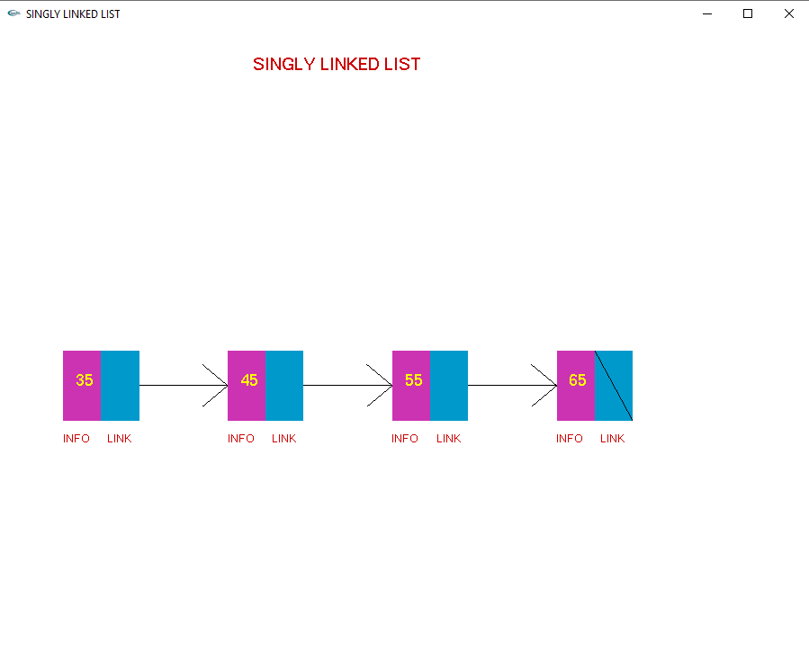
Fig 4.1: Singly Linked list

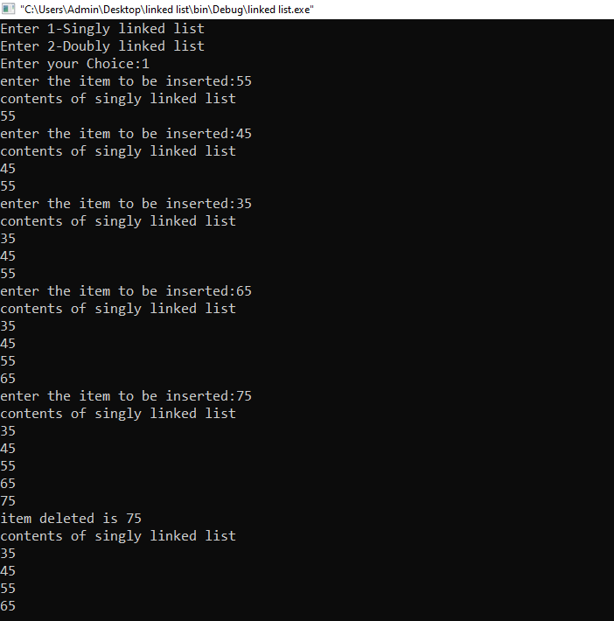
Fig 4.2: Operations on Singly linked list

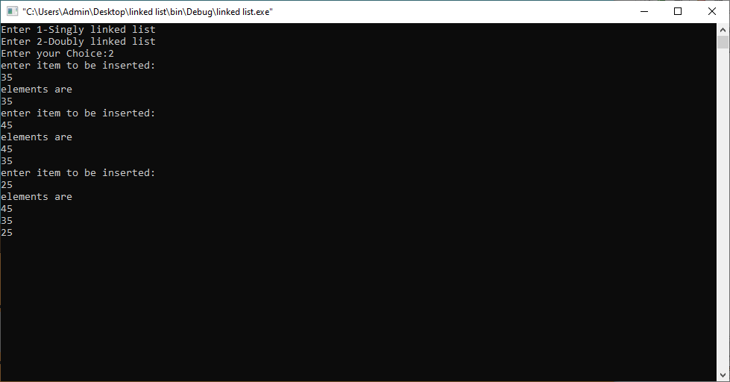
Fig 4.3: Insert Operations on Doubly Linked list

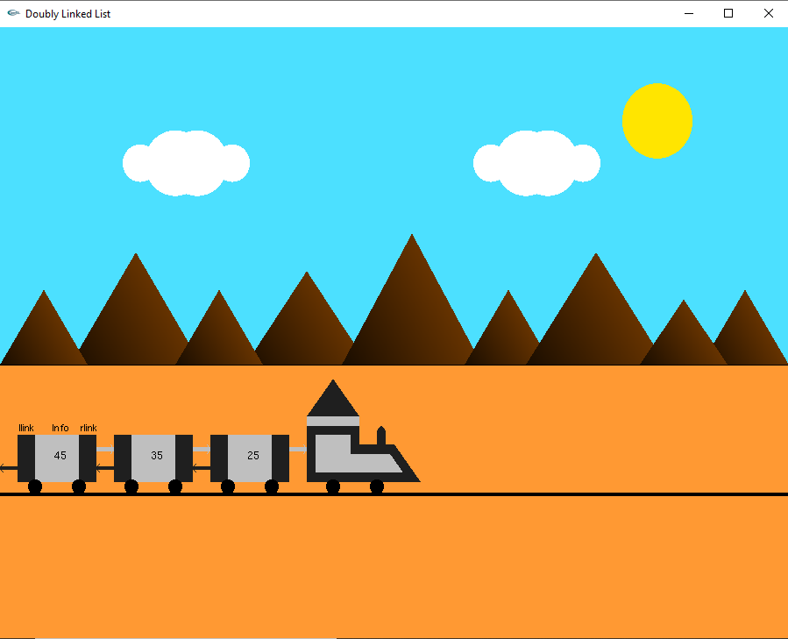
Fig 4.4: Doubly linked list which is Occupied
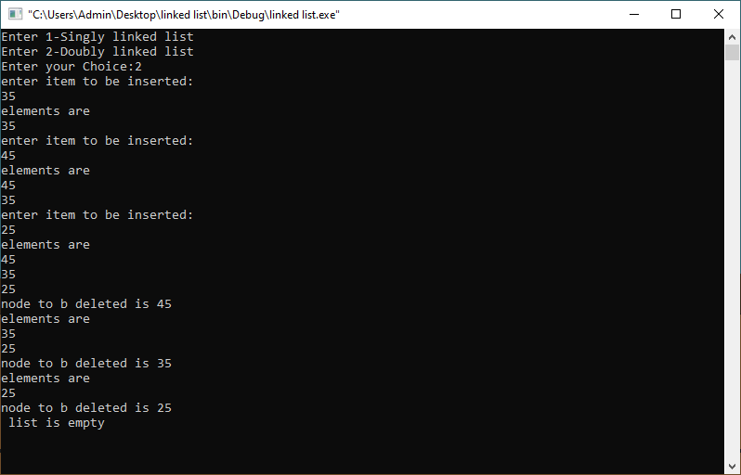
Fig 4.5: Delete Operations on Doubly Linked list

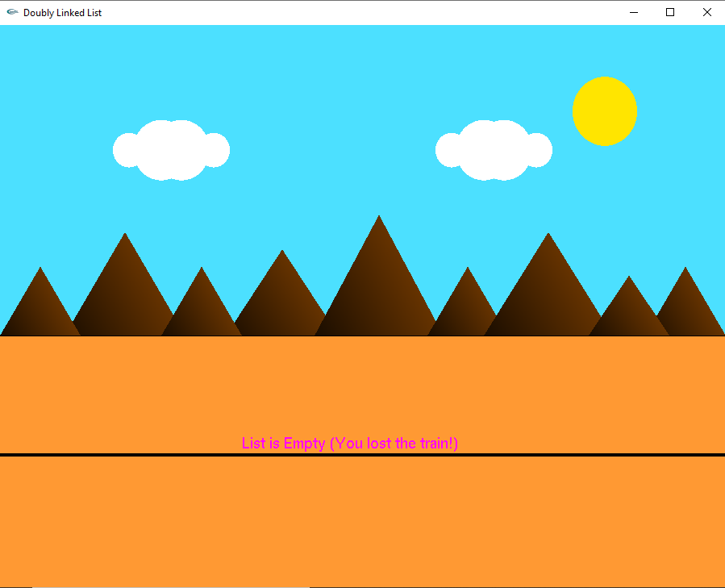
Fig 4.6: Doubly linked list which is empty
CHAPTER 5

CONCLUSION AND FUTURE SCOPE
By implementing this project, I got to know how to use some of the built-in functions effectively and how to interact efficiently and easily. I got a good exposure of how games, animation and simulations are developed, by working on this project.

The OpenGL Utility Toolkit (GLUT) is a programming interface with ANSI C bindings for writing window system independent OpenGL programs.

One of the major accomplishments in the specification of OpenGL was the isolation of window system dependencies from OpenGL’s rendering model. The result is that OpenGL is window system independent. Window system operations such as the creation of a rendering window and the handling of window system events are left to the native window system to define. Necessary interactions between OpenGL and the window system such as creating and binding an OpenGL context to a window are described separately from the OpenGL specification in a window system dependent specification.

The GLUT application-programming interface (API) requires very few routines to display a graphics scene rendered using OpenGL. The GLUT API (like the OpenGL API) is stateful. Most initial GLUT state is defined and the initial state is reasonable for simple programs. The GLUT routines also take relatively few parameters. No pointers are returned. The only pointers passed into GLUT are pointers to character strings (all strings passed to GLUT are copied, not referenced) and opaque font handles.

